
Getting Started Guide

Chapter 5
Getting Started with Calc
Using Spreadsheets in LibreOffice

Copyright
This document is Copyright © 2018 by the LibreOffice Documentation Team. Contributors are listed below. You may distribute it and/or modify it under the terms of either the GNU General Public License (http://www.gnu.org/licenses/gpl.html), version 3 or later, or the Creative Commons Attribution License (http://creativecommons.org/licenses/by/4.0/), version 4.0 or later.
All trademarks within this guide belong to their legitimate owners.

Contributors
Amanda Labby | Jorge Rodriguez | Olivier Hallot
Dave Barton | Paul Figueiredo | Jean Hollis Weber

Feedback
Please direct any comments or suggestions about this document to the Documentation Team’s mailing list: documentation@global.libreoffice.org
Note: Everything you send to a mailing list, including your email address and any other personal information that is written in the message, is publicly archived and cannot be deleted.

Acknowledgments
This chapter is based on Chapter 5 of Getting Started with OpenOffice.org 4.1. The contributors to that chapter are:
Jean Hollis Weber | Peter Schofield | David Michel
Hazel Russman | Ron Faile Jr. | Martin Saffron
John A Smith | Olivier Hallot | Dave Koelmeyer
Leo Moons

Publication date and software version
Published 15 February 2018. Based on LibreOffice 6.0.

Note for Mac users
Some keystrokes and menu items are different on a Mac from those used in Windows and Linux. The table below gives some common substitutions for the instructions in this chapter. For a more detailed list, see the application Help.
Windows or Linux | Mac equivalent | Effect
Tools > Options menu selection | LibreOffice > Preferences | Access setup options
Right-click | Control+click and/or right-click depending on computer setup | Open a context menu
Ctrl (Control) | ⌘ (Command) | Used with other keys
F5 | Shift+⌘+F5 | Open the Navigator
F11 | ⌘+T | Open the Styles and Formatting window

Contents
Copyright 2
Contributors 2
Feedback 2
Acknowledgments 2
Publication date and software version 2
Note for Mac users 2
What is Calc? 7
Compatibility with other spreadsheet applications 7
Wildcards 7
Formula syntax 7
Macros 7
Spreadsheets, sheets, and cells 7
Calc main window 8
Title bar 8
Menu bar 8
Toolbars 9
Formula bar 9
Status bar 10
Sidebar 10
Spreadsheet layout 11
Individual cells 11
Sheet tabs 11
Opening a CSV file 12
Saving spreadsheets 14
Saving in other spreadsheet formats 14
Exporting contents as image 15
Navigating within spreadsheets 15
Cell navigation 15
Sheet navigation 16
Keyboard navigation 17
Customizing the Enter key 18
Selecting items in a spreadsheet 19
Selecting cells 19
Single cell 19
Range of contiguous cells 19
Range of non-contiguous cells 20
Selecting columns and rows 20
Single column or row 20
Multiple columns or rows 20
Entire sheet 20
Selecting sheets 21
Single sheet 21
Multiple contiguous sheets 21
Multiple non-contiguous sheets 21
All sheets 21
Hiding and showing sheets 21
Working with columns and rows 21
Inserting columns and rows 21
Single column or row 21
Multiple columns or rows 22
Deleting columns and rows 22
Single column or row 22
Multiple columns or rows 22
Working with sheets 23
Inserting new sheets 23
Moving and copying sheets 23
Dragging and dropping 23
Using a dialog 24
Deleting sheets 24
Renaming sheets 25
Viewing Calc 25
Changing document view 25
Freezing rows and columns 25
Freezing rows or columns 26
Unfreezing 26
Splitting the screen 26
Splitting horizontally or vertically 26
Removing split views 27
Using the keyboard 27
Numbers 27
Minus numbers 27
Leading zeroes 27
Numbers as text 28
Text 29
Date and time 29
Autocorrection options 30
Replace 30
Exceptions 30
Options 30
Localized options 30
Reset 30
Deactivating automatic changes 30
Speeding up data entry 31
Using the Fill tool 31
Using a fill series 31
Defining a fill series 33
Defining a fill series from a range in a sheet 33
Using selection lists 33
Sharing content between sheets 34
Validating cell contents 34
Editing data 35
Deleting data 35
Deleting data only 35
Deleting data and formatting 35
Replacing data 35
Changing data 35
Using the keyboard 35
Using the mouse 36
Formatting data 36
Multiple lines of text 36
Automatic wrapping 36
Manual line breaks 37
Shrinking text to fit the cell 37
Formatting numbers 37
Formatting fonts and text in cells 38
Formatting cell borders 39
Formatting cell background 39
Formatting default cell styles 39
AutoFormatting of cells 39
Using AutoFormat 39
Defining a new AutoFormat 40
Using themes 40
Using conditional formatting 42
Hiding and showing data 42
Hiding data 42
Showing data 43
Cell protection 43
Sorting records 45
Cell comments 45
Using formulas and functions 46
The Function Wizard and Function Search 46
Analyzing data 47
Pivot tables and pivot charts 47
Pivot charts 48
Printing 48
Print ranges 48
Defining a print range 48
Adding to a print range 48
Removing a print range 49
Editing a print range 49
Printing options 49
Repeat printing of rows or columns 50
Page breaks 50
Inserting a break 50
Deleting a page break 50
Headers and footers 51
Setting a header or footer 51

What is Calc?
Calc is the spreadsheet component of LibreOffice. You can enter data (usually numerical) in a spreadsheet and then manipulate this data to produce certain results.
Alternatively, you can enter data and then use Calc in a “What if...” manner by changing some of the data and observing the results without having to retype the entire spreadsheet or sheet.
Other features provided by Calc include:
- Functions, which can be used to create formulas to perform complex calculations on data.
- Database functions, to arrange, store, and filter data.
- Dynamic charts; a wide range of 2D and 3D charts.
- Macros, for recording and executing repetitive tasks; scripting languages supported include LibreOffice Basic, Python, BeanShell, and JavaScript.
- Ability to open, edit, and save Microsoft Excel spreadsheets.
- Import and export of spreadsheets in multiple formats, including HTML, CSV, PDF, and PostScript.

Compatibility with other spreadsheet applications

Wildcards
Simple wildcards such as the asterisk (*), question mark (?), and tilde (~) from other spreadsheet applications are recognized by LibreOffice. Wildcards are more widespread in other spreadsheet applications and adopting a similar option in LibreOffice allows for better compatibility and a better experience for users who may not be familiar with the use of regular expressions.

Formula syntax
By default, LibreOffice Calc uses its own formula syntax, referred to as Calc R1 rather than the Excel R1 syntax that is used by Microsoft Excel. LibreOffice will translate seamlessly between the two. However, if you are familiar with Excel you may wish to change the default syntax in Calc by going to Tools > Options > LibreOffice Calc > Formula > Formula Syntax and choosing Excel R1 from the drop-down menu provided.
For more information on formula syntax, see the Calc Guide Chapter 7 Formulas and Functions.

Macros
Microsoft Office uses Visual Basic for applications (VBA) code, and LibreOffice uses Basic code based on the LibreOffice API. Although the programming languages are the same, the objects and methods are different and therefore not entirely compatible.
LibreOffice can however run some Excel Visual Basic Scripts if you enable this feature at Tools > Options > Load/Save > VBA Properties.
For more information on macros, refer to the Calc Guide Chapter 12 Calc Macros.

Spreadsheets, sheets, and cells
Calc works with documents called spreadsheets. Spreadsheets consist of a number of individual sheets, each sheet containing cells arranged in rows and columns. A particular cell is identified by its row number and column letter.
Cells hold the individual elements – text, numbers, formulas, and so on – that make up the data to display and manipulate.
Each spreadsheet can have several sheets, and each sheet can have many individual cells. In Calc, each sheet can have a maximum of 1,048,576 rows and a maximum of 1024 columns. LibreOffice Calc can hold up to 32,000 sheets.

Calc main window
When Calc is started, the main window opens (Figure 1). The parts of this window are described below.

Title bar
The Title bar, located at the top, shows the name of the current spreadsheet. When a spreadsheet is newly created from a template or a blank document, its name is Untitled X, where X is a number. When you save a spreadsheet for the first time, you are prompted to enter a name of your choice.
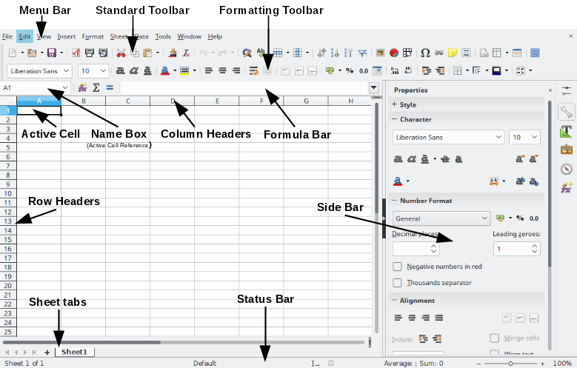
Figure 1: Calc main window

Menu bar
When you select an item on the Menu bar, a sub-menu drops down to show commands. You can also customize the Menu bar; see Chapter 14 Customizing LibreOffice for more information.
- File – contains commands that apply to the entire document; for example, Open, Save, Wizards, Export as PDF, Print, Digital Signatures, and Templates.
- Edit – contains commands for editing the document; for example, Undo, Copy, Paste, Track Changes, Find and Replace, Compare and Merge Documents.
- View – contains commands for modifying how the Calc user interface looks; for example, Toolbars, Grids, Column & Row Headers, Full Screen, Zoom.
- Insert – contains commands for inserting elements into a spreadsheet; for example, Pictures, Media, Objects, Formula Design, Frames, Special Characters, Charts, Functions, Shapes, Pivot Tables, Named Ranges, Comments, Hyperlinks, Headers and Footers, Form Controls.
- Format – contains commands for modifying the layout of a spreadsheet; for example, Cells, Page, Styles, Alignment, Merge Cells, Print Range, Conditional Formatting, Spreadsheet Themes, Image, Chart, Object.
- Styles – contains commands to apply standard styles to cell, group of cells or sheets contents.
- Sheet – contains the most often used commands for handling sheets, such as Insert and Delete Cells, Columns, Rows and Sheets, Sheets from File, Cell Reference Type, Link to External Data, as well as Comments and Fill cells.
- Data – contains commands for manipulating data in the spreadsheet; for example, Define Database Range, Sort, Filters, Statistics, Pivot Tables, Consolidate, Forms, Groups and Outlines.
- Tools – contains various functions to help you check and customize the spreadsheet; for example, Spelling, Share Document, Gallery, Macros, Goal Seek, Solver, Detective, Protect Sheet, XML Filter Settings, Extension Manager.
- Window – contains commands to open a New window or Close an open window.
- Help – contains links to the LibreOffice help system and other miscellaneous functions; for example, Help, License Information, User Guides, Check for Updates, Send Feedback, and Donate.

Toolbars
The default setting when Calc opens is for the Standard and Formatting toolbars to be docked at the top of the workspace (Figure 1).
Calc toolbars can be either docked and fixed in place, or floating; you can move a toolbar into a more convenient position on the workspace. Docked toolbars can be undocked and either moved to different docked position on the workspace, or left as a floating toolbar. Toolbars that are floating when opened can be docked into a fixed position on the workspace.
You can choose the single-toolbar alternative to the default double toolbar arrangement. It contains the most-used commands. To activate it, enable View > Toolbars > Standard (Single Mode) and disable View > Toolbars > Standard and View > Toolbars > Formatting.
The default set of icons (sometimes called buttons) on toolbars provides a wide range of common commands and functions. You can also remove or add icons to toolbars; see Chapter 14 Customizing LibreOffice for more information. When hovering the toolbar with the mouse, a tool tip shows the action performed by each icon in the toolbar.

Formula bar
The Formula Bar (Figure 2) is located at the top of the sheet in the Calc workspace. The Formula Bar is permanently docked in this position and cannot be used as a floating toolbar. If the Formula Bar is not visible, go to View on the Menu bar and select Formula Bar.
Figure 2: Formula bar
From left to right, the Formula Bar consists of the following:
- Name Box – gives the current active cell reference using a combination of a letter and number, for example A1. The letter indicates the column and the number indicates the row of the selected cell. If you have selected a range of cells that is also a named range, the name of the range is shown in this box. You can also type a cell reference in the Name Box to jump to the referenced cell. If you type the name of a named range and press the Enter key, the named range is selected and displayed.
- Function Wizard – opens a dialog from which you can search through a list of available functions. This can be very useful because it also shows how the functions are formatted.
- Sum – clicking on the Sum icon totals the numbers in the cells above the selected cell and then places the total in the selected cell. If there are no numbers above the selected cell, then the cells to the left are totaled. When the Sum icon is used, Calc suggest the range to sum with a colored box, but does not insert the formula. You need to confirm the suggested range by typing Enter, or reject pressing Esc. You can also adjust the range with the mouse by dragging the colored box or its edges to adjust the range. The icons in the formula bar are equivalent to the Enter and Esc commands.
- Function – clicking on the Function icon inserts an equals (=) sign into the selected cell and the Input line, allowing a formula to be entered. The Name box now displays the most frequently used functions, for a quick access to the function name and syntax.
- Input line – displays the contents of the selected cell (data, formula, or function) and allows you to edit the cell contents. To turn the Input line into a multiline input area for very long formulas, click the drop down button on the right.
You can also edit the contents of a cell directly in the cell itself by double-clicking on the cell. When you enter new data into a cell, the Sum and Function icons change to Cancel and Accept icons.
- Note
In a spreadsheet the term “function” covers much more than just mathematical functions. See the Calc Guide Chapter 7 Using Formulas and Functions for more information.

Status bar
The Calc status bar (Figure 3) provides information about the spreadsheet as well as quick and convenient ways to change some of its features. Most of the fields are similar to those in other components of LibreOffice; see Chapter 1 Introducing LibreOffice in this guide and the Calc Guide Chapter 1 Introducing Calc for more information.
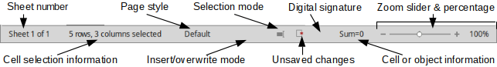
Figure 3: Calc status bar
The status bar has a quick way to do some math operations on selected cells in the spreadsheet. You can calculate average and sum, count elements, and more on the selection by right-clicking over the cell information area of the status bar and selecting the operations you want to display in the status bar (Figure 10).

Sidebar
The Calc Sidebar (View > Sidebar) is located on the right side of the window. It is a mixture of toolbar and dialog. It is similar to the sidebar in Writer (shown in Chapter 1 and Chapter 4 of this book) and consists of five decks: Properties, Styles, Gallery, Navigator, and Functions. Each deck has a corresponding icon on the Tab panel to the right of the sidebar, allowing you to switch between them. The decks are described below.
- Properties: This deck includes five content panels.
- Styles: Access to the available cell styles, update cell styles, and new cell styles.
- Character: Controls for formatting the text, such as font family, size, and color. Some controls, such as superscript, only become active when the text cursor is active in the Input line of the Formula bar or the cell.
- Number Format: Quickly change the format of numbers including decimals, currency, dates, or numeric text. Numerical and label field controls for Forms are also available.
- Alignment: Controls to align the text in various ways, including horizontal and vertical alignment, wrapping, indenting, merging, text orientation, and vertical stacking.
- Cell Appearance: Controls to set the appearance options, including cell background color, cell border formats including line color and style, and grid lines.
Each of these panels has a More Options button, which opens a dialog giving a greater number of options. These dialogs lock the document for editing until they are closed.
- Styles: This deck contains a single panel, which is the same as that opened by selecting the Styles button (F11) from the Text Formatting toolbar.
- Gallery: This deck contains a single panel, which is the same as that opened by selecting Gallery from the Standard toolbar or Tools > Gallery from the Menu bar.
- Navigator: This deck contains a single panel, which is essentially the same as the Navigator window opened by clicking the Navigator button on the Standard toolbar or selecting View > Navigator (F5) from the Menu bar. Only the Contents button is absent in the Sidebar’s Navigator panel.
- Functions: This deck contains a single panel, which is the same as the window opened by selecting Insert > Function... from the Menu bar.
To the right side of the title bar of each open deck is a Close button (X), which closes the deck to leave only the Tab bar open. Clicking on any Tab button reopens the deck.
To hide the Sidebar, or reveal it if already hidden, click on the edge Hide/Show button. To adjust the deck width, drag on the left edge of the sidebar.

Spreadsheet layout

Individual cells
The main section of the workspace in Calc displays the cells in the form of a grid. Each cell is formed by the intersection of one column and one row in the spreadsheet.
At the top of the columns and the left end of the rows are a series of header boxes containing letters and numbers. The column headers use an alpha character starting at A and go on to the right. The row headers use a numerical character starting at 1 and go down.
These column and row headers form the cell references that appear in the Name Box on the Formula Bar (Figure 2). If the headers are not visible on the spreadsheet, go to View on the Menu bar and select Column & Row Headers.

Sheet tabs
In Calc, you can have more than one sheet in a spreadsheet. At the bottom of the grid of cells in a spreadsheet are sheet tabs indicating how many sheets there are in the spreadsheet. Clicking on a tab enables access to each individual sheet and displays that sheet. An active sheet is indicated with a white tab (default Calc setup). You can also select multiple sheets by holding down the Ctrl key while clicking on the sheet tabs.
To change the default name for a sheet (Sheet1, Sheet2, and so on), right-click on a sheet tab and select Rename Sheet from the context menu or double click on the sheet tab to open a dialog to let you type a new name for the sheet. Click OK when finished to close the dialog.
To change the color of a sheet tab, right-click on the tab and select Tab Color from the context menu to open the Tab Color dialog. Select a color and click OK when finished to close the dialog. To add new colors to this color palette, see Chapter 14 Customizing LibreOffice.

Opening a CSV file
Comma-separated-values (CSV) files are spreadsheet files in a text format where cell contents are separated by a character, for example a comma or semicolon. Each line in a CSV text file represents a row in a spreadsheet. Text is entered between quotation marks; numbers are entered without quotation marks.
- Note
Most CSV files come from databases tables, queries, or reports, where further calculations and charting are required. On Microsoft Windows, CSV files often have the XLS file name extension to look like an Excel file, but they are still CSV files internally.
To open a CSV file in Calc:
- Choose File > Open on the Menu bar and locate the CSV file that you want to open.
- Select the file and click Open. By default, a CSV file has the extension .csv. However, some CSV files may have a .txt extension.
- The Text Import dialog (Figure 4) opens. Here you can select the various options available when importing a CSV file into a Calc spreadsheet.
- Click OK to open and import the file.
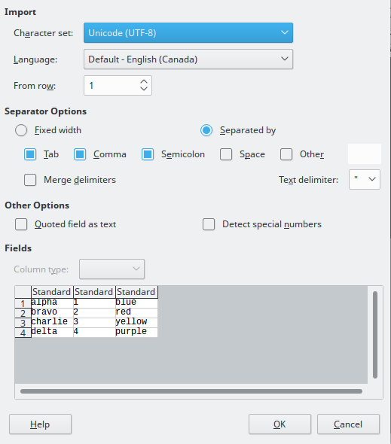
Figure 4: Text Import dialog
The options for importing CSV files into a Calc spreadsheet are as follows:
- Import
- Character Set – specifies the character set to be used in the imported file.
- Language – determines how the number strings are imported.
If Language is set to Default for CSV import, Calc will use the globally set language. If Language is set to a specific language, that language will be used when importing numbers.
- From Row – specifies the row where you want to start the import. The rows are visible in the preview window at the bottom of the dialog.
- Separator Options – specifies whether the data uses separators or fixed widths as delimiters.
- Fixed width – separates fixed-width data (equal number of characters) into columns. Click on the ruler in the preview window to set the width.
- Separated by – select the separator used in the data to delimit the data into columns. If you select Other, specify the character used to separate data into columns. This custom separator must also be contained in the data.
- Merge delimiters – combines consecutive delimiters and removes blank data fields.
- Text delimiter – select a character to delimit text data.
- Other Options
- Quoted fields as text – when this option is enabled, fields or cells whose values are quoted in their entirety (the first and last characters of the value equal the text delimiter) are imported as text.
- Detect special numbers – when this option is enabled, Calc will automatically detect all number formats, including special number formats such as dates, time, and scientific notation. The selected language also influences how such special numbers are detected, since different languages and regions many have different conventions for such special numbers.
When this option is disabled, Calc will detect and convert only decimal numbers. The rest, including numbers formatted in scientific notation, will be imported as text. A decimal number string can have digits 0-9, thousands separators, and a decimal separator. Thousands separators and decimal separators may vary with the selected language and region.
- Fields – shows how the data will look when it is separated into columns.
- Column type – select a column in the preview window and select the data type to be applied the imported data.
- Standard – Calc determines the type of data.
- Text – imported data are treated as text.
- US English – numbers formatted in US English are searched for and included regardless of the system language. A number format is not applied. If there are no US English entries, the Standard format is applied.
- Hide – the data in the column are not imported.

Saving spreadsheets
To save a spreadsheet, see Chapter 1 Introducing LibreOffice for more details on how to save files manually or automatically. Calc can also save spreadsheets in a range of formats and also export spreadsheets to PDF, HTML, XHTML file formats and JPEG and PNG images formats; see the Calc Guide Chapter 6 Printing, Exporting, and E-mailing for more information.

Saving in other spreadsheet formats
If you need to exchange files with users who are unable to receive spreadsheet files in Open Document Format (ODF) (*.ods), which Calc uses as default format, you can save a spreadsheet in another format.
- Save the spreadsheet in Calc spreadsheet file format (*.ods).
- Select File > Save As on the Menu bar to open the Save As dialog (Figure 5).
- In File name, you can enter a new file name for the spreadsheet.
- In the File type drop-down menu, select the type of spreadsheet format you want to use.
- If Automatic file name extension is selected, the correct file extension for the spreadsheet format you have selected will be added to the file name.
- Click Save.
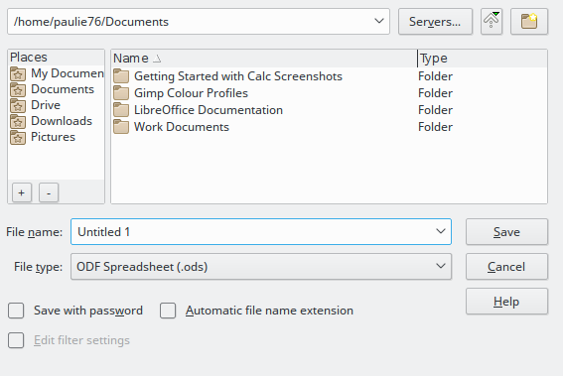
Figure 5: Save As dialog
- When saving in a non default file format, the Confirm File Format dialog opens (Figure 6). Click Use [xxx] Format to continue saving in your selected spreadsheet format or click Use ODF Format to save the spreadsheet in Calc ODS format.
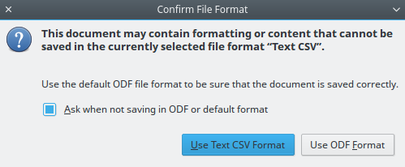
Figure 6: Confirm File Format dialog
- If you select Text CSV format (*.csv) for your spreadsheet, the Export Text File dialog (Figure 7) may open. Here you can select the character set, field delimiter, text delimiter, and so on to be used for the CSV file.
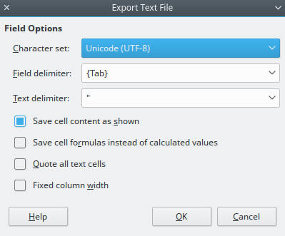
Figure 7: Export Text File dialog for CSV files
- Tip
To have Calc save documents by default in a file format other than the default ODF format, go to Tools > Options > Load/Save > General. In Default file format and ODF settings > Document type, select Spreadsheet, then in Always save as, select your preferred file format.

Exporting contents as image
If you want to send a fragment of your spreadsheet to a colleague, business partner or publish it in the internet, Calc can export a range selection or a selected group of shapes (images) to a PNG or JPG graphics format:
- Select the range or the group of shapes in your spreadsheet.
- Select File – Export... to open the Export dialog.
- Enter a name for your image in the File name box.
- Select the graphics file format in the Type list
- Mark the Selection checkbox in the Export dialog.
- Click Export...

Navigating within spreadsheets
Calc provides many ways to navigate within a spreadsheet from cell to cell and sheet to sheet. You can generally use the method you prefer.

Cell navigation
When a cell is selected or in focus, the cell borders are emphasized. When a group of cells is selected, the cell area is colored. The color of the cell border emphasis and the color of a group of selected cells depends on the operating system being used and how you have set up LibreOffice.
- Using the mouse – place the mouse pointer over the cell and click the left mouse button. To move the focus to another cell using the mouse, simply move the mouse pointer to the cell where you want the focus to be and click the left mouse button.
- Using a cell reference – highlight or delete the existing cell reference in the Name Box on the Formula Bar (Figure 2 on page 9). Type the new cell reference of the cell you want to move to and press Enter key. Cell references are case-insensitive: for example, typing either a3 or A3 will move the focus to cell A3.
- Using the Navigator – press the F5 key to open the Navigator dialog (Figure 8) or click the Navigator button in the open Sidebar. Type the cell reference into the Column and Row fields and press the Enter key.
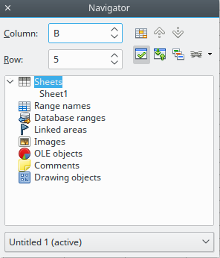
Figure 8: Navigator in Calc
- Using the Enter key – pressing Enter moves the cell focus down in a column to the next row. Pressing Shift+Enter moves the focus up in a column to the previous row.
- Using the Tab key – pressing Tab moves the cell focus right in a row to the next column. Pressing Shift+Tab moves the focus to the left in a row to the previous column.
- Using the arrow keys – pressing the arrow keys on the keyboard moves the cell focus in the direction of the arrow pressed.
- Using Home, End, Page Up and Page Down
- Home moves the cell focus to the start of a row.
- End moves the cell focus to the last cell on the right in the row in the right-most column that contains data.
- Page Down moves the cell focus down one complete screen display.
- Page Up moves the cell focus up one complete screen display.

Sheet navigation
Each sheet in a spreadsheet is independent of the other sheets, though references can be linked from one sheet to another. There are three ways to navigate between sheets in a spreadsheet:
- Using the Navigator – when the Navigator is open (Figure 8), double-click on any of the listed sheets to select the sheet.
- Using the keyboard – use key combinations Ctrl+Page Down to move one sheet to the right and Ctrl+Page Up to move one sheet to the left.
- Using the mouse – click on one of the sheet tabs at the bottom of the spreadsheet to select that sheet.
If your spreadsheet contains a lot of sheets, then some of the sheet tabs may be hidden. If this is the case:
- Using the four buttons to the left of the sheet tabs can move the tabs into view (Figure 9).
- Right-clicking on any of the arrows opens a context menu where you can select a sheet (see Figure 10).
- Note
When you insert a new sheet into a spreadsheet, Calc automatically uses the next number in the numeric sequence as a name. Depending on which sheet is open when you insert a new sheet, and the insertion method you use, the new sheet may not be in its correct numerical position. It is recommended to rename sheets in a spreadsheet to make them more recognizable.
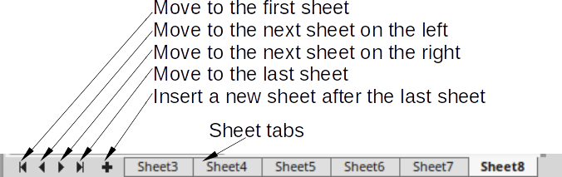
Figure 9: Navigating sheet tabs

Figure 10: Right-click any arrow button

Keyboard navigation
To navigate a spreadsheet using the keyboard, pressing a key or a combination of keys. For a key combination, press more than one key at the same time. Table 1 lists the keys and key combinations you can use for spreadsheet navigation in Calc.
Table 1. Keyboard cell navigation
Keyboard shortcut | Cell navigation
→ | Moves cell focus right one cell.
← | Moves cell focus left one cell.
↑ | Moves cell focus up one cell.
↓ | Moves cell focus down one cell
Ctrl+→ | Moves cell focus to the first column on the right containing data in that row if cell focus is on a blank cell.  Moves cell focus to the last column on the right in the same range of occupied cells in that row if cell focus is on a cell containing data.  Moves cell focus to the last column on the right in the spreadsheet if there are no more cells containing data.
Ctrl+← | Moves cell focus to the last column on the left containing data in that row if cell focus is on a blank cell.  Moves cell focus to the first column on the left in the same range of occupied cells in that row if cell focus is on a cell containing data.  Moves cell focus to the first column in that row if there are no more cells containing data.
Ctrl+↑ | Moves cell focus from a blank cell to the first cell above containing data in the same column.  Moves cell focus to the first row in the same range of occupied cells if cell focus is on a cell containing data.  Moves cell focus from the last cell containing data to the cell in the same column in the first row of the spreadsheet.
Ctrl+↓ | Moves cell focus from a blank cell to the first cell below containing data in the same column.  Moves cell focus to the last row in the same range of occupied cells in that column if cell focus is on a cell containing data.  Moves cell focus from the last cell containing data to the cell in the same column in the last row of the spreadsheet.
Ctrl+Home | Moves cell focus from anywhere on the spreadsheet to Cell A1 on the same sheet.
Ctrl+End | Moves cell focus from anywhere on the spreadsheet to the last cell in the lower right-hand corner of the rectangular area of cells containing data on the same sheet.
Alt+Page Down | Moves cell focus one screen to the right (if possible).
Alt+Page Up | Moves cell focus one screen to the left (if possible).
Ctrl+Page Down | Moves cell focus to the cell on the next sheet to the right in sheet tabs where the focus was there before; if the spreadsheet has more than one sheet.
Ctrl+Page Up | Moves cell focus to the cell on the next sheet to the left in sheet tabs where the focus was there before; if the spreadsheet has more than on sheet.
Tab | Moves cell focus to the next cell on the right.
Shift+Tab | Moves cell focus to the next cell on the left.
Enter | Moves cell focus down one cell (unless changed by user). See the next topic.
Shift+Enter | Moves cell focus up one cell (unless changed by user).

Customizing the Enter key
You can customize the direction in which the Enter key moves the cell focus by going to Tools > Options > LibreOffice Calc > General. Select the direction cell focus moves from the drop-down list. Depending on the file being used or the type of data being entered, setting a different direction can be useful. The Enter key can also be used to switch into and out of editing mode. Use the first two options under Input settings in Figure 11 to change the Enter key settings.
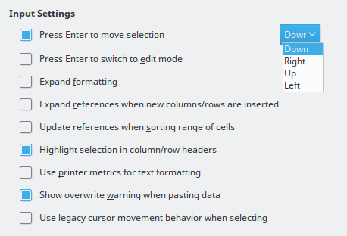
Figure 11: Customizing the Enter key

Selecting items in a spreadsheet

Selecting cells

Single cell
Left-click in the cell. You can verify your selection by looking in the Name Box on the Formula Bar (Figure 2 on page 9).

Range of contiguous cells
A range of cells can be selected using the keyboard or the mouse.
To select a range of cells by dragging the mouse cursor:
- Click in a cell.
- Press and hold down the left mouse button.
- Move the mouse around the screen.
- Once the desired block of cells is highlighted, release the left mouse button.
To select a range of cells without dragging the mouse:
- Click in the cell which is to be one corner of the range of cells.
- Move the mouse to the opposite corner of the range of cells.
- Hold down the Shift key and click.
- Tip
You can also select a contiguous range of cells by first clicking in the Selection mode field on the Status Bar (Figure 3 on page 10) and selecting Extending selection before clicking in the opposite corner of the range of cells. Make sure to change back to Standard selection or you may extend a cell selection unintentionally.
To select a range of cells without using the mouse:
- Select the cell that will be one of the corners in the range of cells.
- While holding down the Shift key, use the cursor arrows to select the rest of the range.
- Tip
You can also directly select a range of cells using the Name Box. Click into the Name Box on the Formula Bar (Figure 2 on page 9). To select a range of cells, enter the cell reference for the upper left-hand cell, followed by a colon (:), and then the lower right-hand cell reference. For example, to select the range that would go from A3 to C6, you would enter A3:C6.

Range of non-contiguous cells
- Select the cell or range of cells using one of the methods above.
- Move the mouse pointer to the start of the next range or single cell.
- Hold down the Ctrl key and click or click-and-drag to select another range of cells to add to the first range.
- Repeat as necessary.
- Note: Some Calc operations cannot be used with non-contiguous cells. For example, you cannot copy a non-contiguous range.

Selecting columns and rows

Single column or row
To select a single column, click on the column header (Figure 1 on page 8).
To select a single row, click on the row header.

Multiple columns or rows
To select multiple columns or rows that are contiguous:
- Click on the first column or row in the group.
- Hold down the Shift key.
- Click the last column or row in the group.
To select multiple columns or rows that are not contiguous:
- Click on the first column or row in the group.
- Hold down the Ctrl key.
- Click on all of the subsequent columns or rows while holding down the Ctrl key.

Entire sheet
To select the entire sheet, click on the corner box between the column header A and the row header 1 (Figure 12), or use the key combination Ctrl+A to select the entire sheet, or go to Edit on the Menu bar and select Select All.
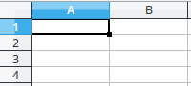
Figure 12: Select All box

Selecting sheets
You can select one or multiple sheets in Calc. It can be advantageous to select multiple sheets, especially when you want to make changes to many sheets at once.

Single sheet
Click on the sheet tab for the sheet you want to select. The tab for the selected sheet becomes white (default Calc setup).

Multiple contiguous sheets
To select multiple contiguous sheets:
- Click on the sheet tab for the first desired sheet.
- Move the mouse pointer over the sheet tab for the last desired sheet.
- Hold down the Shift key and click on the sheet tab.
- All tabs between these two selections will turn white (default Calc setup). Any actions that you perform will now affect all highlighted sheets.

Multiple non-contiguous sheets
To select multiple non-contiguous sheets:
- Click on the sheet tab for the first desired sheet.
- Move the mouse pointer over the sheet tab for the second desired sheet.
- Hold down the Ctrl key and click on the sheet tab.
- Repeat as necessary.
- The selected tabs will turn white (default Calc setup). Any actions that you perform will now affect all highlighted sheets.

All sheets
Right-click a sheet tab and choose Select All Sheets from the context menu.

Hiding and showing sheets
Sometimes you may want to hide the contents of a sheet to preserve data from accidental editing or because its contents are not important to display. To hide a sheet or many sheets, select the sheet or sheets as above, right-click to open the context menu, and select Hide Sheet. To show hidden sheets, right-click any sheet tab and select Show Sheet on the context menu. A dialog will appear with all hidden sheets listed. Click on the desired sheet and then click OK.
- Tip
LibreOffice Calc does not let you hide the last visible sheet.

Working with columns and rows

Inserting columns and rows

Single column or row
Using the Sheet menu:
- Select a cell, column, or row where you want the new column or row inserted.
- Go to Sheet on the Menu bar and select either Insert > Columns > Columns Left or > Columns Right or Insert > Rows > Rows Above or > Rows Below.
Using the mouse:
- Select a column or row where you want the new column or row inserted.
- Right-click the column or row header.
- Select Insert Columns Left, Insert Columns Right, Insert Rows Above, or Insert Rows Below from the context menu.

Multiple columns or rows
Multiple columns or rows can be inserted at once rather than inserting them one at a time.
- Highlight the required number of columns or rows by holding down the left mouse button on the first one and then dragging across the required number of identifiers.
- Proceed as for inserting a single column or row above.

Deleting columns and rows

Single column or row
To delete a single column or row:
- Select a cell in the column or row you want to delete.
- Go to Sheet on the Menu bar and select Delete Cells or right-click and select Delete from the context menu.
- Select the option you require from the Delete Cells dialog (Figure 13).
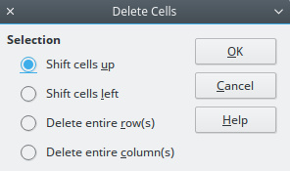
Figure 13: Delete Cells dialog
Alternatively:
- Click in the column or header to select the column or row.
- Go to Sheet on the Menu bar and select Delete Cells or right-click and select Delete Columns or Delete Rows from the context menu.

Multiple columns or rows
To delete multiple columns or rows:
- Select the columns or rows, see “Multiple columns or rows” on page 20 for more information.
- Go to Sheet on the Menu bar and select Delete Cells, or right-click and select Delete Columns or Delete Rows from the context menu.

Working with sheets

Inserting new sheets
Click on the Add Sheet icon on the bottom of the screen to insert a new sheet after the last sheet in the spreadsheet without opening the Insert Sheet dialog. The following methods open the Insert Sheet dialog (Figure 14), where you can position the new sheet, create more than one sheet, name the new sheet, or select a sheet from a file.
- Select the sheet where you want to insert a new sheet, then go to Sheet > Insert Sheet... on the Menu bar.
- Right-click on the sheet tab where you want to insert a new sheet and select Insert Sheet from the context menu.
- Click in the empty space at the end of the sheet tabs.
- Right-click in the empty space at the end of the sheet tabs and select Insert Sheet from the context menu.
You can insert several sheets by specifying the number of sheets to insert.
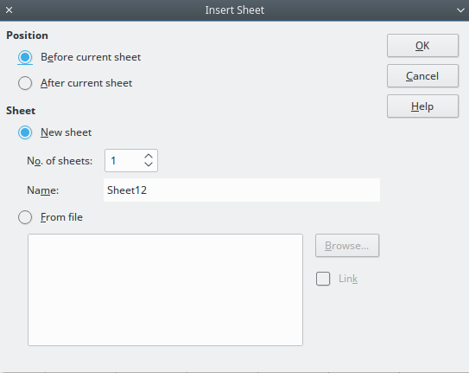
Figure 14: Insert Sheet dialog

Moving and copying sheets
You can move or copy sheets within the same spreadsheet by dragging and dropping, or by using the Move/Copy Sheet dialog. To move or copy a sheet into a different spreadsheet, you have to use the Move/Copy Sheet dialog.

Dragging and dropping
To move a sheet to a different position within the same spreadsheet, click and hold on the sheet tab and drag it to its new position before releasing the mouse button.
To copy a sheet within the same spreadsheet, hold down the Ctrl key (Option key on Mac) then click on the sheet tab and drag it to its new position before releasing the mouse button. The mouse pointer may change to include a plus sign depending on the setup of your operating system.

Using a dialog
Use the Move/Copy Sheet dialog (Figure 15) to specify exactly whether you want the sheet in the same or a different spreadsheet, its position within the spreadsheet, and the sheet name when you move or copy the sheet.
- In the current document, right-click on the sheet tab you wish to move or copy and select Move/Copy Sheet from the context menu or go to Sheet > Move or Copy Sheet... on the Menu bar.
- Select Move to move the sheet or Copy to copy the sheet in the Action area.
- Select the spreadsheet where you want the sheet to be placed from the drop-down list in To document. This can be the same spreadsheet, another spreadsheet already open, or a new spreadsheet.
- Select the position in Insert before where you want to place the sheet.
- Type a name in the New name text box if you want to rename the sheet when it is moved or copied. If you do not enter a name, Calc creates a default name (Sheet 2, Sheet 3, and so on).
- Click OK to confirm the move or copy and close the dialog.
- Caution
When you move or copy to another spreadsheet or a new spreadsheet, a conflict may occur with formulas linked to other sheets in the previous location.
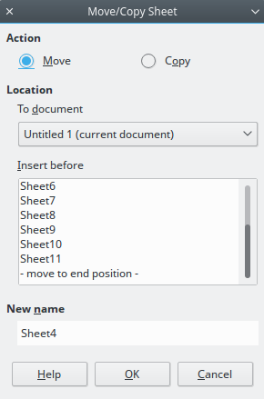
Figure 15: Move/Copy Sheet dialog

Deleting sheets
To delete a single sheet, right-click on the sheet tab you want to delete and select Delete Sheet from the context menu, or go to Sheet > Delete Sheet... on the Menu bar. Click Yes to confirm the deletion.
To delete multiple sheets, select the sheets (see “Selecting sheets” on page 21), then right-click one of the sheet tabs and select Delete Sheet from the context menu, or go to Sheet > Delete Sheet... from on the Menu bar. Click Yes to confirm the deletion.

Renaming sheets
By default, the name for each new sheet added is SheetX, where X is the number of the next sheet to be added. While this works for a small spreadsheet with only a few sheets, it can become difficult to identify sheets when a spreadsheet contains many sheets.
You can rename a sheet using one of the following methods:
- Enter the name in the Name text box when you create the sheet using the Insert Sheet dialog (Figure 14 on page 23).
- Right-click on a sheet tab and select Rename Sheet from the context menu to replace the existing name with a different one.
- Double-click on a sheet tab to open the Rename Sheet dialog.
- Note
Sheet names must start with either a letter or a number; other characters, including spaces, are not allowed. Apart from the first character of the sheet name, permitted characters are letters, numbers, spaces, and the underscore character. Attempting to rename a sheet with an invalid name will produce an error message.

Viewing Calc

Changing document view
Use the zoom function to show more or fewer cells in the window when you are working on a spreadsheet. For more about zoom, see Chapter 1 Introducing LibreOffice in this guide.

Freezing rows and columns
Freezing locks a number of rows at the top of a spreadsheet or a number of columns on the left of a spreadsheet or both rows and columns. Then, when moving around within a sheet, the cells in frozen rows and columns always remain in view.
Figure 16 shows some frozen rows and columns. The heavier horizontal line between rows 3 and 23 and the heavier vertical line between columns F and Q indicate that rows 1 to 3 and columns A to F are frozen. The rows between 3 and 23 and the columns between F and Q have been scrolled off the page.
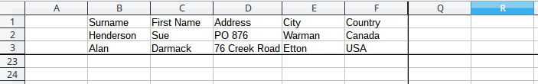
Figure 16: Frozen rows and columns

Freezing rows or columns
- Click into the cell that is immediately below the rows you want to freeze and immediately to the right of the columns you want frozen.
- Click on the Freeze Rows and Columns icon in the main toolbar or go to View on the Menu bar and select Freeze Cells > Freeze Rows and Columns. A heavier line appears between the rows or columns indicating where the freeze has been placed.

Unfreezing
To unfreeze rows or columns, either go to View on the Menu bar and select Freeze Cells > Freeze Rows and Columns or click on the Freeze Rows and Columns icon in the main toolbar. The heavier lines indicating freezing will disappear.

Splitting the screen
Another way to change the view is by splitting the screen your spreadsheet is displayed in (also known as splitting the window). The screen can be split horizontally, vertically, or both, giving you up to four portions of the spreadsheet in view at any one time. An example of splitting the screen is shown in Figure 17 where a split is indicated by additional window borders within the sheet.
Why would you want to do this? For example, consider a large spreadsheet in which one cell contains a number that is used by three formulas in other cells. Using the split-screen technique, you can position the cell containing the number in one section and each of the cells with formulas in the other sections. You can then change the number in one cell and watch how it affects each of the formulas.

Figure 17: Split screen example

Splitting horizontally or vertically
- Click on the row header below the rows where you want to split the screen horizontally or click on the column header to the right of the columns where you want to split the screen vertically.
- Go to View on the Menu bar and select Split Window. Window borders appear between the rows or columns indicating where the split has been placed, as shown in Figure 18.
Alternatively:
- For a horizontal split, drag the new horizontal window border beneath the row where you want the horizontal split positioned.
- For a vertical split, drag the new vertical window border across to the right of the column where you want the vertical split positioned.
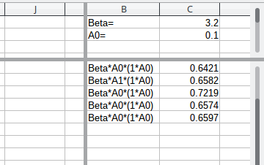
Figure 18: Split screen window borders

Removing split views
To remove a split view, do one of the following:
- Drag the split window borders back to their places at the ends of the scroll bars.
- Go to View on the Menu bar and deselect Split Window.

Using the keyboard
Most data entry in Calc can be accomplished using the keyboard.

Numbers
Click in the cell and type in a number using the number keys on either the main keyboard or numeric keypad. By default, numbers are right aligned in a cell.

Minus numbers
To enter a negative number, either type a minus (–) sign in front of the number or enclose the number in parentheses (), for example (1234). The result for both methods of entry will be the same, for example -1234.

Leading zeroes
To retain a minimum number of integer characters in a cell when entering numbers in order to retain the number format, for example 1234 and 0012, leading zeros have to be added using one of the following methods.
Method 1
- With the cell selected, right-click on the cell, select Format Cells from the context menu or go to Format > Cells on the Menu bar or use the keyboard shortcut Ctrl+1 to open the Format Cells dialog (Figure 19).
- Make sure the Numbers tab is selected then select Number in the Category list.
- In Options > Leading Zeros, enter the minimum number of characters required. For example, for four characters, enter 4. Any number less than four characters will have leading zeros added, for example 12 becomes 0012.
- Click OK. The number entered retains its number format and any formula used in the spreadsheet will treat the entry as a number in formula functions.
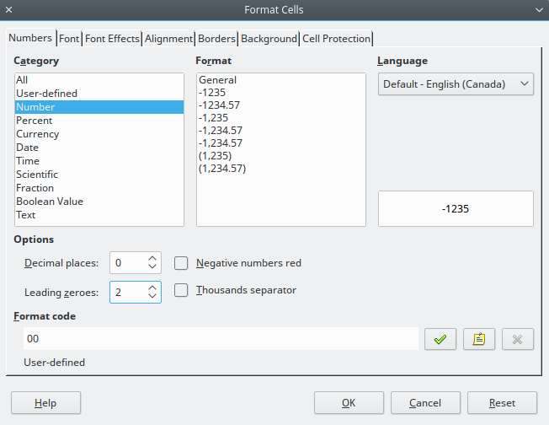
Figure 19: Format Cells dialog – Numbers page
Method 2
- Select the cell.
- Open the Sidebar (View > Sidebar) and click the Open Panel (+) icon on the Number Format panel to open it.
- Select Number in the Category list box.
- Set the Leading zeroes value box to 4. Formatting is applied immediately.
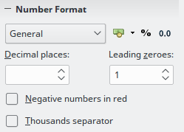
Figure 20: Set Leading zeroes
If a number is entered with leading zeroes, for example 01481, without first setting the Leading zeros parameter, then by default Calc will automatically drop the leading 0. To preserve leading zeros in a number:
- Type an apostrophe (') before the number, for example '01481.
- Move the cell focus to another cell. The apostrophe is automatically removed, the leading zeros are retained and the number is converted to text left aligned.

Numbers as text
Numbers can also be entered as text using one of the following methods.
Method 1
- With the cell selected, right-click on the cell and select Format Cells from the context menu or go to Format > Cells on the Menu bar or use the keyboard shortcut Ctrl+1 to open the Format Cells dialog (Figure 19).
- Make sure the Numbers page is selected, then select Text from the Category list.
- Click OK and the number, when entered, is converted to text and, by default, left aligned.
Method 2
- Select the cell.
- Open the Sidebar (View > Sidebar) and click the Open Panel (+) icon on the Number Format panel.
- Select Text in the Category list box. Formatting is applied to the cell immediately.
- Click back on the cell. Enter the number and move focus from the cell to have the data formatted.
- Note
By default, any numbers that have been formatted as text in a spreadsheet will be treated as a zero by any formulas used in the spreadsheet. Formula functions will ignore text entries. You can change this feature in Tools – Options – LibreOffice – Calc – Formula, in Detailed Calculation Settings, select Custom (conversion of text to numbers and more) and then select the proper treatment in the Convert from text to numbers drop down list.

Text
Click in the cell and type the text. By default, text is left-aligned in a cell.

Date and time
Select the cell and type the date or time.
You can separate the date elements with a slash (/) or a hyphen (–) or use text, for example 10 Oct 2012. The date format automatically changes to the selected format used by Calc.
When entering a time, separate time elements with colons, for example 10:43:45. The time format automatically changes to the selected format used by Calc.
To change the date or time format used by Calc, use one of the following methods.
Method 1
- With the cell selected, right-click on the cell and select Format Cells from the context menu, or go to Format > Cells on the Menu bar, or use the keyboard shortcut Ctrl+1, to open the Format Cells dialog (Figure 19).
- Make sure the Numbers page is selected, then select Date or Time from the Category list.
- Select the date or time format you want to use from the Format list. Click OK.
Method 2
- With the cell selected, open the Sidebar (View > Sidebar) and (if necessary) click the Open Panel (+) icon on the Number Format panel (Figure Error: Reference source not found).
- Select Date in the Category list box.
- Click the More Options button in the panel title bar to open the Format Cells dialog.
- Select the date or time format you want to use from the Format list. Click OK.

Autocorrection options
Calc automatically applies many changes during data input using autocorrection, unless you have deactivated any autocorrect changes. You can also undo any autocorrection changes by using the keyboard shortcut Ctrl+Z or manually by going back to the change and replacing the autocorrection with what you want to actually see.
To change the autocorrect options, go to Tools > AutoCorrect Options on the Menu bar to open the AutoCorrect dialog (Figure 21).

Replace
Edits the replacement table for automatically correcting or replacing words or abbreviations in the document.

Exceptions
Specify the abbreviations or letter combinations that you do not want LibreOffice to correct automatically.

Options
Select the options for automatically correcting errors as you type and then click OK.

Localized options
Specify the AutoCorrect options for quotation marks and for options that are specific to the language of the text.

Reset
Resets modified values back to the LibreOffice default values.
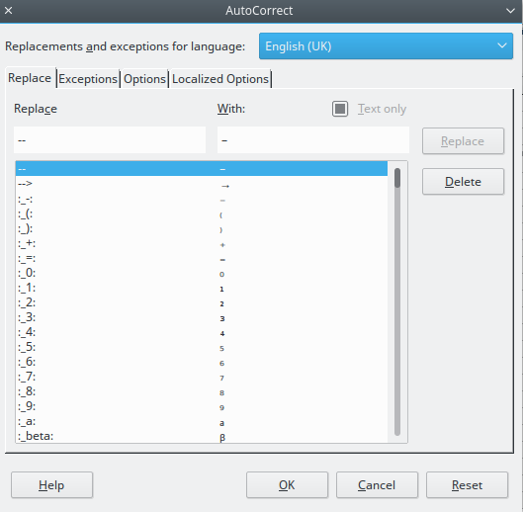
Figure 21: AutoCorrect dialog

Deactivating automatic changes
Some AutoCorrect settings are applied when you press the spacebar after you enter data. To turn off or on Calc AutoCorrect, go to Tools on the Menu bar and deselect or select AutoInput.

Speeding up data entry
Entering data into a spreadsheet can be very labor-intensive, but Calc provides several tools for removing some of the drudgery from input.
The most basic ability is to drop and drag the contents of one cell to another with a mouse. Many people also find AutoInput helpful. Calc also includes several other tools for automating input, especially of repetitive material. They include the fill tool, selection lists, and the ability to input information into multiple sheets of the same document.

Using the Fill tool
The Calc Fill tool is used to duplicate existing content or create a series in a range of cells in your spreadsheet (Figure 22).
- Select the cell containing the contents you want to copy or start the series from.
- Drag the mouse in any direction or hold down the Shift key and click in the last cell you want to fill.
- Go to Sheet > Fill Cells on the Menu bar and select the direction in which you want to copy or create data (Up, Down, Left or Right) or Series and Random Number... from the submenu.
Alternatively, you can use a shortcut to fill cells.
- Select the cell containing the contents you want to copy or start the series from.
- Move the cursor over the small square in the bottom right corner of the selected cell. The cursor will change shape.
- Click and drag in the direction you want the cells to be filled. If the original cell contained text, then the text will automatically be copied. If the original cell contained a number, a series will be created.
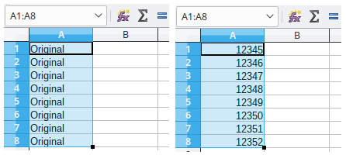
Figure 22: Using the Fill tool

Using a fill series
When you select a series fill from Sheet > Fill Cells > Series..., the Fill Series dialog (Figure 23) opens. Here you can select the type of series you want.
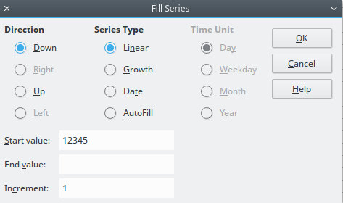
Figure 23: Fill Series dialog
- Direction – determines the direction of series creation.
- Down – creates a downward series in the selected cell range for the column using the defined increment to the end value.
- Right – creates a series running from left to right within the selected cell range using the defined increment to the end value.
- Up – creates an upward series in the cell range of the column using the defined increment to the end value.
- Left – creates a series running from right to left in the selected cell range using the defined increment to the end value.
- Series Type – defines the series type.
- Linear – creates a linear number series using the defined increment and end value.
- Growth – creates a growth series using the defined increment and end value.
- Date – creates a date series using the defined increment and end date.
- AutoFill – forms a series directly in the sheet. The AutoFill function takes account of customized lists. For example, by entering January in the first cell, the series is completed using the list defined in Tools > Options > LibreOffice Calc > Sort Lists. AutoFill tries to complete a value series by using a defined pattern. For example, a numerical series using 1,3,5 is automatically completed with 7,9,11,13; a date and time series using 01.01.99 and 15.01.99, an interval of fourteen days is used.
- Unit of Time – in this area you specify the desired unit of time. This area is only active if the Date option has been chosen in the Series type area.
- Day – use the Date series type and this option to create a series using seven days.
- Weekday – use the Date series type and this option to create a series of five day sets.
- Month – use the Date series type and this option to form a series from the names or abbreviations of the months.
- Year – use the Date series type and this option to create a series of years.
- Start Value – determines the start value for the series. Use numbers, dates or times.
- End Value – determines the end value for the series. Use numbers, dates or times.
- Increment – determines the value by which the series of the selected type increases by each step. Entries can only be made if the linear, growth or date series types have been selected.
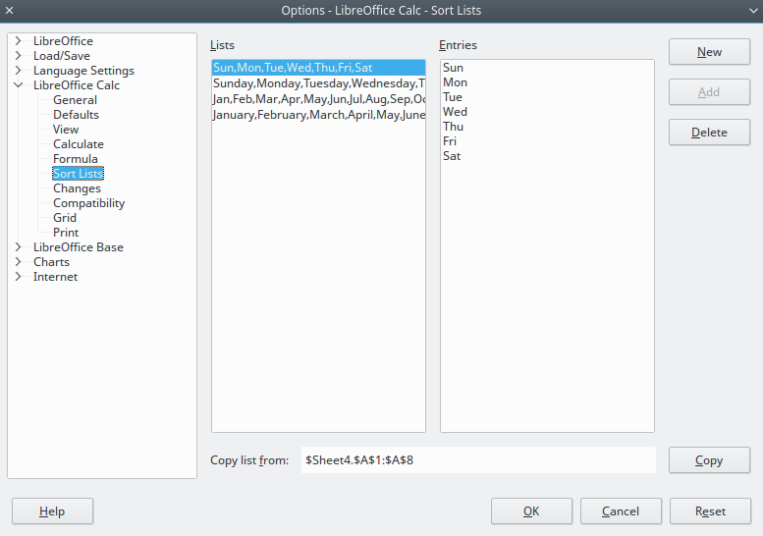
Figure 24: Sort Lists dialog

Defining a fill series
To define your own fill series:
- Go to Tools > Options > LibreOffice Calc > Sort Lists to open the Sort Lists dialog (Figure 24). This dialog shows the previously-defined series in the Lists box on the left and the contents of the highlighted list in the Entries box.
- Click New and the Entries box is cleared.
- Type the series for the new list in the Entries box (one entry per line).
- Click Add and the new list will now appear in the Lists box.
- Click OK to save the new list.

Defining a fill series from a range in a sheet
You can define a range of text values as a fill series.
- Select the range containing the text values that you want to use as a fill series.
- Go to Tools > Options > LibreOffice Calc > Sort Lists to open the Sort List dialog (Figure 24).
- The selected range is in the box Copy list from. Click Copy to add the range to the sort list.

Using selection lists
Selection lists are available only for text and are limited to using only text that has already been entered in the same column.
- Select a blank cell in a column that contains cells with text entries.
- Right-click and select Selection Lists from the context menu. A drop-down list appears listing any cell in the same column that either has at least one text character or whose format is defined as text.
- Click on the text entry you require and it is entered into the selected cell.

Sharing content between sheets
You might want to enter the same information in the same cell on multiple sheets, for example to set up standard listings for a group of individuals or organizations. Instead of entering the list on each sheet individually, you can enter the information in several sheets at the same time.
- Go to Sheet > Select Sheets... on the Menu bar to open the Select Sheets dialog.
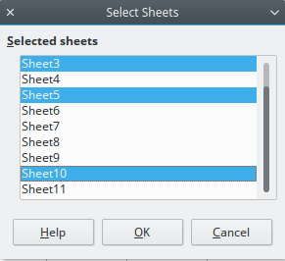
Figure 25: Select Sheets dialog
- Select the individual sheets where you want the information to be repeated. Use the Shift and Ctrl (Options on Mac) keys to select multiple sheets.
- Click OK to select the sheets and the sheet tabs will change color.
- Enter the information in the cells on the first sheet where you want it to appear and it will be repeated in all the selected sheets.
- Note
This technique automatically overwrites, without any warning, any information that is already in the cells on the selected sheets. Make sure you deselect the additional sheets when you are finished entering information that is going to be repeated before continuing to enter data into your spreadsheet.

Validating cell contents
When creating spreadsheets for other people to use, validating cell contents ensures that they enter data that is valid and appropriate for the cell. You can also use validation in your own work as a guide to entering data that is either complex or rarely used.
Fill series and selection lists can handle some types of data, but are limited to predefined information. To validate new data entered by a user, select a cell and go to Data > Validity on the Menu bar to define the type of contents that can be entered in that cell. For example, a cell may require a date or a whole number with no alphabetic characters or decimal points, or a cell may not be left empty.
Depending on how validation is set up, validation can also define the range of contents that can be entered, provide help messages explaining the content rules set up for the cell and what users should do when they enter invalid content. You can also set the cell to refuse invalid content, accept it with a warning, or start a macro when an error is entered. See the Calc Guide Chapter 2 Entering, Editing, and Formatting Data for more information on validating cell contents.

Editing data

Deleting data

Deleting data only
Data can be deleted from a cell without deleting any of the cell formatting. Click in the cell to select it and then press the Delete key.

Deleting data and formatting
Data and cell formatting can be deleted from a cell at the same time.
- Click in the cell to select it.
- Press the Backspace key, or right-click in the cell and select Delete Contents from the context menu, or go to Edit > Delete Contents) on the Menu bar to open the Delete Contents dialog (Figure 26). Here you can delete the different aspects of the data in the cell or to delete everything in the cell.
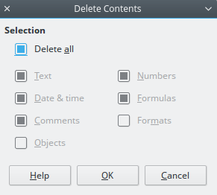
Figure 26: Delete Contents dialog

Replacing data
To completely replace data in a cell and insert new data, select the cell and type in the new data. The new data will replace the data already contained in the cell but will retain the original formatting used in the cell.
Alternatively, select the cell and click in the Input Line on the Formula Bar (Figure 2 on page 9), then double-click on the data to highlight it completely and type the new data.

Changing data
Sometimes it is necessary to edit the contents of cell without removing all of the data from the cell. For example, changing the phrase “Sales in Qtr. 2” to “Sales rose in Qtr” can be done as follows.

Using the keyboard
- Click in the cell to select it.
- Press the F2 key and the cursor is placed at the end of the cell.
- Use the keyboard arrow keys to reposition the cursor where you want to start entering the new data in the cell.
- When you have finished, press the Enter key and your editing changes are saved.

Using the mouse
- Double-click on the cell to select it and place the cursor in the cell for editing.
- Either:
- Reposition the cursor to where you want to start entering the new data in the cell.
- Single-click to select the cell.
- Move the cursor to the Input Line on the Formula Bar (Figure 2 on page 9) and click at the position where you want to start entering the new data in the cell.
- When you have finished, click away from the cell to deselect it and your editing changes are saved.

Formatting data
- Note
All the settings discussed in this section can also be set as a part of the cell style. See the Calc Guide Chapter 4 Using Styles and Templates in Calc for more information.

Multiple lines of text
Multiple lines of text can be entered into a single cell using automatic wrapping or manual line breaks. Each method is useful for different situations.

Automatic wrapping
To automatically wrap multiple lines of text in a cell, use one of the following methods.
Method 1
- Right-click on the cell and select Format Cells from the context menu, or go to Format > Cells on the Menu bar, or press Ctrl+1, to open the Format Cells dialog.
- Click on the Alignment tab (Figure 27).
- Under Properties, select Wrap text automatically and click OK.
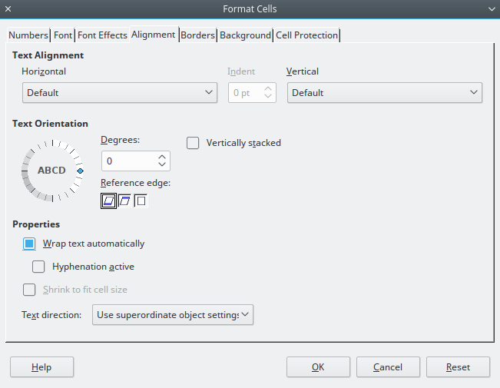
Figure 27: Format Cells dialog – Alignment page
Method 2
- Select the cell.
- Open the Sidebar (View > Sidebar) and click the Open Panel (+) icon on the Alignment panel.
- Select the Wrap text option to apply the formatting immediately.
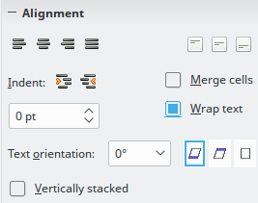
Figure 28: Wrap text formatting

Manual line breaks
To insert a manual line break while typing in a cell, press Ctrl+Enter. When editing text, double-click the cell, then reposition the cursor to where you want the line break. In the input line of the formula bar, press Shift+Enter.
When a manual line break is entered in a cell, the cell row height changes to display all the lines in the cell.

Shrinking text to fit the cell
The font size of the data in a cell can automatically adjust to fit inside cell borders. To do this, select the Shrink to fit cell size option under Properties in the Format Cells dialog (Figure 27) on the Alignment page. This dialog is also available by clicking the More Options button in the Character title bar of the Properties deck on the opened Sidebar, with text in the cell selected.

Formatting numbers
Several different number formats can be applied to cells by using icons on the Formatting toolbar (highlighted in Figure 29). Select the cell, then click the relevant icon to change the number format.
Figure 29: Number icons on Formatting toolbar
For more control or to select other number formats, use the Numbers page of the Format Cells dialog (Figure 19 on page 28):
- Apply any of the data types in the Category list to the data.
- Control the number of decimal places and leading zeros in Options.
- Enter a custom format code.
- The Language setting controls the local settings for the different formats such as the date format and currency symbol.
Some number formats are available from the Sidebar’s Number Format panel in the Properties deck. Click the More Options button to open the Format Cells dialog described above.

Formatting fonts and text in cells
To quickly select a font and format text for use in a cell:
- Select the cell.
- Click the small triangle on the right of the Font Name box on the Formatting toolbar (highlighted in Figure 30) and select a font from the drop-down list.
- Click on the small triangle on the right of the Font Size on the Formatting toolbar and select a font size from the drop down list.
Figure 30: Font Name and Size on Formatting toolbar
- To change the character format, click on the Bold, Italic, or Underline icons.
- To change the horizontal paragraph alignment, click on one of the four alignment icons (Left, Center, Right, Justified) . For more options go to menu Format – Cells – Alignment, and select one of the options in the Horizontal drop down list.
- To change the vertical alignment of the text in the cell, go to menu Format – Cells – Alignment and select one of the options in the Vertical drop down list.
- To change the font color, click the arrow next to the Font Color icon to display the color palette, then select the desired color.
- The Format menu also contains a quick access to direct text formatting in cells (Figure 31).
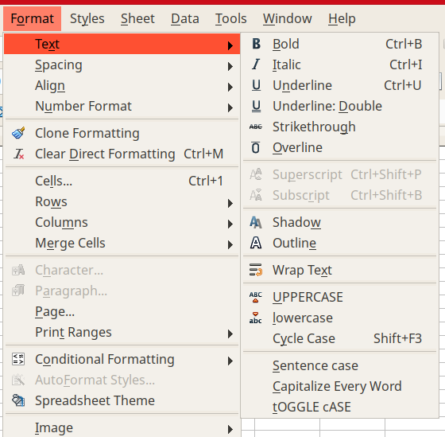Figure 31: Direct formatting through Format menu
The Properties deck of the Sidebar has five panels, Styles, Character, Number Format, Alignment and Cell Appearance, which between them contain all the formatting controls from the Formatting toolbar and more.
To specify the language used in the cell, open the Font page on the Format Cells dialog. You can also select the More Options button on the Character panel of the Sidebar to open the Format Cells dialog. Changing language in a cell allows different languages to be used within the same document.
Use the Font Effects tab on the Format Cells dialog to set other font characteristics. See the Calc Guide Chapter 4 Using Styles and Templates in Calc for more information.

Formatting cell borders
To format the borders of a cell or a group of selected cells, click on the Borders icon on the Formatting toolbar, and select one of the border options displayed in the palette.
To format the border line style, click on the line style icon and select the type from the palette. For the color of the borders lines of a cell, select the Border Color icon. A color palette is displayed.
The Cell Appearance panel of the Properties deck in the Sidebar contains Cell border, Line style and Line color controls.
For more control, including the spacing between cell borders and any data in the cell, use the Borders page of the Format Cells dialog (Figure 19 on page 28), where you can also define a shadow style. Clicking the More Options button on the Cell Appearance title bar, or clicking More in the panel’s line style drop-down list, opens the Format Cells dialog at the Borders page.
See the Calc Guide Chapter 4 Using Styles and Templates in Calc for more information.
- Note
Cell border properties apply only to the selected cells and can be changed only when you are editing those cells. For example, if cell C3 has a top border, that border can only be removed by selecting C3. It cannot be removed in C2 despite also appearing to be the bottom border for cell C2.

Formatting cell background
To format the background color for a cell or a group of cells, click the small arrow next to the Background Color icon on the Formatting toolbar. A color palette, similar to the Font Color palette, is displayed. You can also use the Background tab of the Format Cells dialog (Figure 19 on page 28). The Cell Appearance panel of the Properties deck in the Sidebar contains a Cell background control with a color palette. See the Calc Guide Chapter 4 Using Styles and Templates in Calc for more information.

Formatting default cell styles
To add default styles for a cell or a group of cells, click Format > Styles. A menu displays the default styles. The default styles can be applied, deleted, or modified through the Styles and Formatting deck. You can create and use custom default cell styles for a cell by clicking Format > Styles > New Styles… Enter in a new name for the style or click an existing style name to update that style. Apply, delete, or modify the custom default style in the Styles and Formatting deck.

AutoFormatting of cells

Using AutoFormat
You can use Calc’s AutoFormat feature to format a table (range of cells) quickly and easily. It also let you format different tables of the sheet with the same look and feel very easily. All formatting applied are direct formatting.
- Select the cells in at least three columns and rows, including column and row headers, that you want to format.
- Go to Format > AutoFormat Styles on the Menu bar to open the AutoFormat dialog (Figure 32).
- Select the type of format and format color from the list.
- Select the formatting properties to be included in the AutoFormat function. When selecting or unselecting a formatting property, the AutoFormat dialog displays the change instantly.
- Click OK.
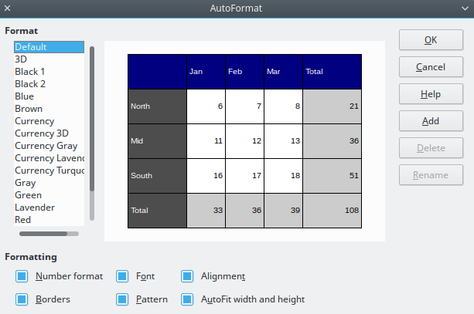
Figure 32: AutoFormat dialog

Defining a new AutoFormat
You can define a new AutoFormat so that it becomes available for use in all spreadsheets.
- Format the data type, font, font size, cell borders, cell background, and so on for a range of cells.
- Select the range.
- Go to Format > AutoFormat to open the AutoFormat dialog. The Add button is now active.
- Click Add.
- In the Name box of the Add AutoFormat dialog that opens, type a meaningful name for the new format.
- Click OK to save. The new AutoFormat is now available in the Format list in the AutoFormat dialog.
- Note
The new AutoFormat is stored in your computer user profile and is not available to other users. However, other users can import the new AutoFormat selecting the table range in the spreadsheet document and defining it as new AutoFormat.

Using themes
Calc comes with a predefined set of formatting themes (set of styles) that you can apply to your spreadsheet. While It is not possible to add new themes in Calc, you can modify the theme styles once the theme is applied to the spreadsheet. The modified styles become available for use in the whole spreadsheet.
To apply a theme to a spreadsheet:
- Click the Choose Themes icon in the Tools toolbar. If this toolbar is not visible, go to View > Toolbars on the Menu bar and select Tools, and the Theme Selection dialog (Figure 33) opens. This dialog lists the available themes for the whole spreadsheet.
- Select the theme that you want to apply. As soon as you select a theme, the theme styles are applied to the spreadsheet and are immediately visible.
- Click OK.
- If you wish, you can now open the Styles window to modify specific styles. These changes do not modify the theme; they only change the appearance of the style in the specific spreadsheet you are creating.
- Caution
Applying a new theme over an existing one will override all existing theme styles customization with the new theme styles.
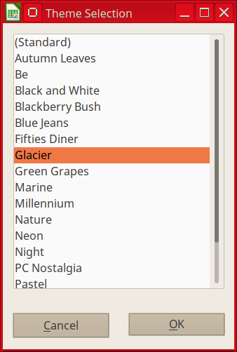
Figure 33: Theme Selection dialog
The applied spreadsheet themes works with cell styles. Some themes even change the Default cell style. A new set of styles, including one named Card is added to your document. Figure 34 shows the styles added by the Pastel theme.
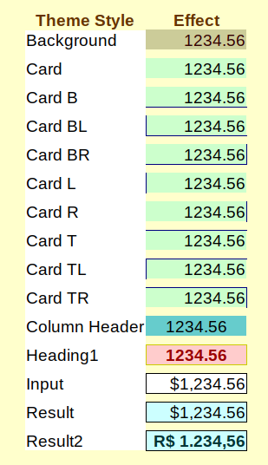
Figure 34: Cell styles of theme "Pastel"

Using conditional formatting
You can set up cell formats to change depending on conditions that you specify. For example, in a table of numbers, you can show all the values above the average in green and all those below the average in red. Multiple formatting options can be entered and arranged using assigned priority rules to order the importance of the conditions, allowing certain formatting options to take place before others, for example.
Conditional formatting depends upon the use of styles and the AutoCalculate feature must be enabled. Go to Tools > Cell Contents > AutoCalculate on the Menu bar to enable this feature. See the Calc Guide Chapter 2 Entering, Editing, and Formatting Data for more information.

Hiding and showing data
In Calc you can hide elements so that they are neither visible on a computer display nor printed when a spreadsheet is printed. However, hidden elements can still be selected for copying if you select the elements around them. For example, if column B is hidden, it is copied when you select columns A and C.
For more information on how to hide and show data, including how to use outline groups and filtering, see the Calc Guide Chapter 2 Entering, Editing, and Formatting Data.
- Note
When data in cells are hidden, the blank cells remain visible in the spreadsheet.

Hiding data
To hide sheets, select them, then go to Sheet > Hide Sheets on the Menu bar, or right-click and choose Hide Sheets on the context menu. You cannot hide all the sheets in a spreadsheet; at least one sheet must remain visible.
To hide rows or columns:
- Select the row or column you want to hide.
- Go to Format on the Menu bar and select Rows or Columns.
- Select Hide from the submenu and the row or column can no longer viewed or printed.
Alternatively, right-click on the row header or column header and select Hide Rows or Hide Columns from the context menu.

Showing data
To show hidden sheets, rows, and columns:
- Select the sheets, rows or columns each side of the hidden sheet, row or column.
- Go to Format on the Menu bar and select Sheet, Row or Column.
- Select Show from the menu and the sheet, row or column will be displayed and can be printed.
Alternatively, right-click on the sheet tabs, row headers or column headers and select Show from the context menu.
- Note
If the first column (A) or first row (1) is hidden, you must select the whole sheet to access the show command for this row or column.

Cell protection
All or some of the cells in a spreadsheet can be password protected to prevent changes being made by unauthorized users. This can be handy when multiple people have access to the spreadsheet itself, but for various reasons only a few can be allowed to modify the data it contains.
By default, all cells will be flagged as Protected (Figure 35).
Before protecting the sheet, you may wish to select certain cells that will be unprotected that can be changed by any users without the password.
To do this:
- Using any of the methods previously discussed, select the cells that you wish to unprotect.
- Open the Format Cells dialog by right-clicking and selecting Format Cells or by selecting Format > Cells from the Menu bar.
- From the Cell Protection tab of the Format Cells dialog, the Protected status of individual or groups of cells can be toggled on or off.
In the Cell Protection tab of the Format Cells dialog is also the option to Hide all data contained in protected cells.
To toggle the hidden status of protected cells:
- Go to Tools > Protect Sheet.
- Enter the password to unprotect the sheet and click OK.
- Go to Format > Cells on the Menu bar, or right-click and select Format Cells from the context menu, or use the keyboard shortcut Ctrl+1 to open the Format Cells dialog.
- Click the Cell Protection tab (Figure 35) and deselect the hide options for the cells.
- Click OK.
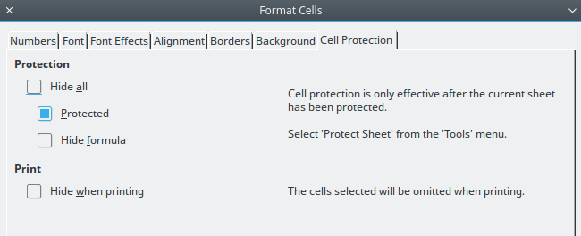
Figure 35: Cell Protection page in Format Cells dialog
When all desired cells have been flagged with either a protected or unprotected status:
- Go to Tools > Protect Sheet. The Protect Sheet dialog will open (Figure 36).
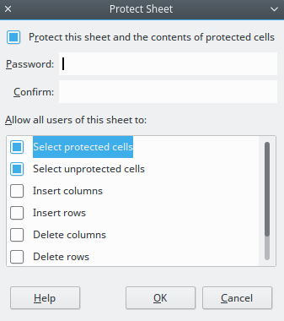
Figure 36: Protect Sheet dialog
- Select Protect this sheet and the contents of protected cells.
- Type a password and then confirm the password.
- Select or deselect the user selection options for cells.
- Click OK.
Any cells that had been toggled as protected will no longer be editable by anyone that does not have the password.
Alternatively, you can choose to protect the entire spreadsheet rather than individual cells on individual sheets by selecting Tools > Protect Spreadsheet from the Menu bar. The protected sheets has a lock icon in its tab, as shown in Figure 37.
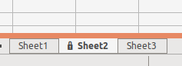Figure 37: The lock icon in a protected sheet

Sorting records
Sorting within Calc arranges the cells in a sheet using the sort criteria that you specify. Several criteria can be used and a sort applies each criteria consecutively. Sorts are useful when you are searching for a particular item and become even more useful after you have filtered data.
Also, sorting is useful when you add new information to your spreadsheet. When a spreadsheet is long, it is usually easier to add new information at the bottom of the sheet, rather than adding rows in their correct place. After you have added information, you then carry out a sort to update the spreadsheet.
For more information on how to sort records and the sorting options available, see the Calc Guide Chapter 2 Entering, Editing, and Formatting Data.
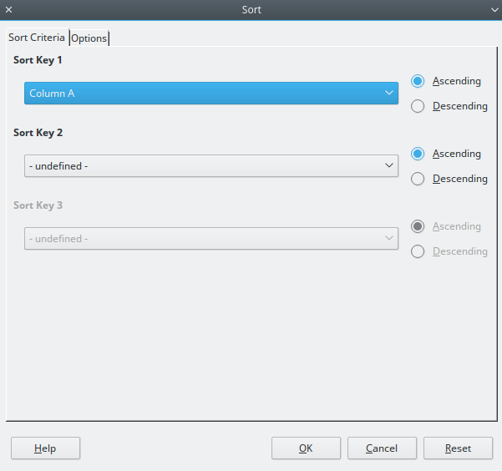
Figure 38: Sort Criteria dialog
To sort cells in a spreadsheet:
- Select the cells to be sorted.
- Go to Data > Sort on the Menu bar to open the Sort dialog (Figure 38).
- Select the sort criteria from the drop down lists. The selected lists are populated from the selected cells.
- Select either ascending order (A-Z, 1-9) or descending order (Z-A, 9-1).
- Click OK and the sort is carried out on your spreadsheet.

Cell comments
Comments are small notes and text that can serve as a reminder or an aside to the user. A comment is not considered a part of the spreadsheet for calculation or printing purposes, and will only appear when hovering the mouse over the particular cell that has been ‘commented’.
The easiest way to insert a comment is by right-clicking on the desired cell and selecting Insert Comment from the Context Menu that appears. Alternatively, a comment can be inserted by selecting Insert > Comment from the Menu bar, by pressing the keyboard shortcut (Ctrl+Alt+C), or by clicking the icon in the Standard Toolbar.
By default, comments will remain hidden and only appear when hovering the mouse. Cells that contain comments are marked with a red square in the upper right corner. To toggle the visibility of comments, select View > Comments from the Menu bar.

Using formulas and functions
You may need more than numbers and text on your spreadsheet. Often the contents of one cell depend on the contents of other cells. Formulas are equations that use numbers and variables to produce a result. Variables are placed in cells to hold data required by equations.
A function is a predefined calculation entered in a cell to help you analyze or manipulate data. All you have to do is enter the arguments and the calculation is made automatically. Functions help you create the formulas required to get the results that you are looking for.

The Function Wizard and Function Search
Functions and formulas can be entered directly into the formula bar or by accessing the function wizard. To launch the function wizard, click the Function Wizard icon to the right of the Name box.
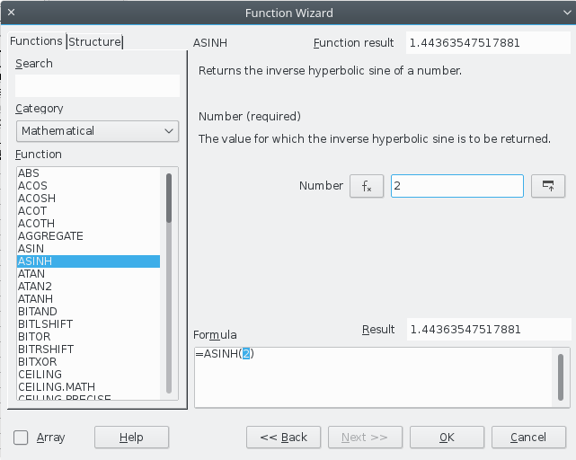Figure 39: Function Wizard with Search Bar
Inside the function wizard, you can search, list, and narrow down the many Calc functions available. You can also choose to complete functions from within the wizard rather than having to type full formulas into the formula bar.
Each function, when selected, will display a brief explanation of its use and acceptable syntax. It will also display dialog boxes where you can enter the information required by that function and a result window showing the expected calculation from the data entered.
- Note
A fast alternative to the function wizard, the Calc Sidebar contains a Functions tab which allows you to quickly list and narrow down functions and provides brief explanations on their use and syntax, but does not provide the search or data entry functionalities of the full wizard.
For a more in-depth introduction to formulas and the function wizard, see the Calc Guide Chapter 7 Formulas and Functions.

Analyzing data
Calc includes several tools to help you analyze the information in your spreadsheets, ranging from features for copying and reusing data, to creating subtotals automatically, to varying information to help you find the answers you need. These tools are divided between the Tools and Data menus.
Calc also includes many tools for statistical analysis of data, where you can obtain important numerical information on data obtained from physical measurements, polls, or even business transactions such as sales, stock quotations, and so on. These statistical data analyses are available in the menu Data > Statistics.
See the Calc Guide Chapter 9 Data Analysis for more information on the tools available in Calc to analyze your data.

Pivot tables and pivot charts
One of the most useful tools for analyzing data is the Pivot Table.
A pivot table is a way to organize, manipulate, and summarize large amounts of data to make it much easier to read and understand while also allowing you to answer different questions about your spreadsheet by rearranging --or pivoting-- the data you enter into it.
For example, let’s say that you have a spreadsheet containing a list of donations to various charities by a group of recruiters in various months, but you are only interested in how much money each recruiter has collected in total. To determine your solution, you could manually calculate that amount by using the sorting and formatting options provided by Calc.
Alternatively, however, you could arrange a pivot table as shown below to make that data easier to organize and read.
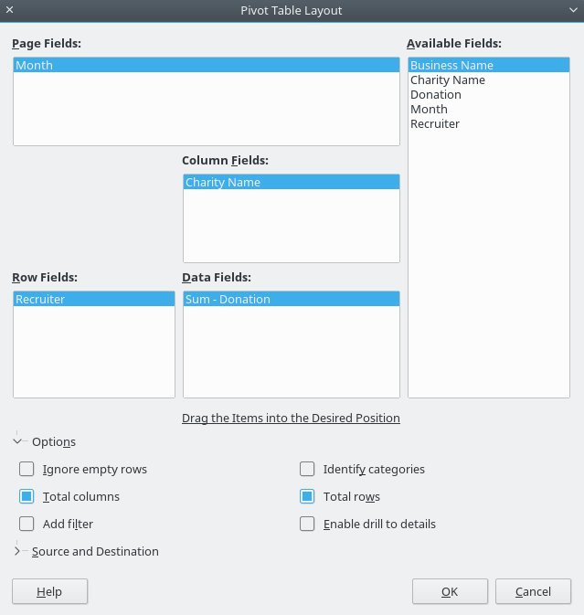Figure 40: Pivot Table dialog with raw data and results
To access the pivot table creation dialog, choose Insert > Pivot Table or Data > Pivot Table > Create from the Menu bar. The Pivot Table Layout dialog will intelligently guess the column headings from the provided raw data and insert them into the Available Fields selection box. From there, you can drag and drop your desired information into column, row, or page fields to organize accordingly and press OK to view the results.
To choose new information to display, or to alter the layout of the existing information, right-click anywhere in the existing pivot table to bring up the context menu and choose Edit Layout.
For a more in-depth explanation of pivot tables, see the Calc Guide Chapter 8 Pivot Tables.

Pivot charts
To get a quick visual representation of the data contained in a pivot table, a Pivot Chart can be generated.
Functionally, pivot charts are nearly identical to regular charts except in two key areas. First, as the data in the pivot table is altered, the pivot chart will adjust itself automatically to follow suit. The second difference is the inclusion of Field Buttons; graphical elements that allow you to filter the content of the pivot table from within the pivot chart itself, which is a useful time-saver if your pivot table and pivot chart are contained on different sheets.
For more information on Pivot Charts and Charts in general, see the Calc Guide Chapter 3 Charts and Graphs and the Calc Guide Chapter 8 Pivot Tables.

Printing
Printing from Calc is much the same as printing from other LibreOffice components (see Chapter 10 Printing, Exporting, and Emailing in this guide). However, some details for printing in Calc are different, especially regarding preparation for printing.

Print ranges
Print ranges have several uses, including printing only a specific part of the data or printing selected rows or columns on every page. For more information about using print ranges, see the Calc Guide Chapter 6 Printing, Exporting, and E-mailing.

Defining a print range
To define a new print range or modify an existing print range:
- Select the range of cells to be included in the print range.
- Go to Format > Print Ranges > Define on the Menu bar. Page break lines are displayed on screen.
- To check the print range, go to File > Print Preview on the Menu bar or click on the Print Preview icon. LibreOffice will display the cells in the print range.

Adding to a print range
After defining a print range, you can add more cells to it by creating another print range. This allows multiple, separate areas of the same sheet to be printed while not printing the whole sheet.
- After defining a print range, select an extra range of cells for adding to the print range.
- Go to Format > Print Ranges > Add on the Menu bar to add the extra cells to the print range. The page break lines are no longer displayed on the screen.
- To check the print ranges, go to File > Print Preview on the Menu bar or click on the Print Preview icon. LibreOffice will display the print ranges as separate pages.
- Note
The additional print range will print as a separate page, even if both ranges are on the same sheet.

Removing a print range
It may become necessary to remove a defined print range, for example, if the whole sheet needs to be printed later.
To remove all the defined print ranges, go to Format > Print Ranges > Remove on the Menu bar. After the print ranges have been removed, the default page break lines will appear on the screen.

Editing a print range
At any time, you can directly edit the print range, for example to remove or resize part of the print range. Go to Format > Print Ranges > Edit on the Menu bar to open the Edit Print Ranges dialog where you can define the print range.

Printing options
To select the printing options for page order, details, and scale to be used when printing a spreadsheet:
- Go to Format > Page on the Menu bar to open the Page Style dialog (Figure 41).
- Select the Sheet tab and make your selections from the available options.
- Click OK.
For more information on printing options, see the Calc Guide Chapter 6 Printing, Exporting, and E-mailing.
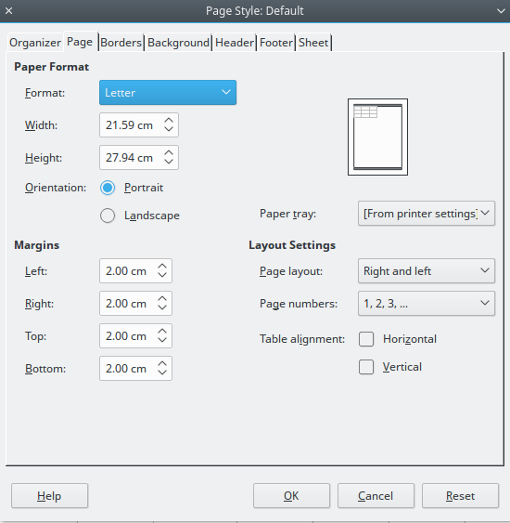
Figure 41: Page Style dialog

Repeat printing of rows or columns
If a sheet is printed on multiple pages, you can set up certain rows or columns to repeat on each printed page. For example, if the top two rows of the sheet as well as column A need to be printed on all pages, do the following:
- Go to Format > Print Ranges > Edit on the Menu bar to open the Edit Print Ranges dialog (Figure 42).
- Type the row identifiers in the Rows to repeat box. For example, to repeat rows 1 and 2, type $1:$2. This automatically changes Rows to repeat from - none - to - user defined -.
- Type the column identifiers in the Columns to repeat box. For example, to repeat column A, type $A. In the Columns to repeat list, - none - changes to - user defined -.
- Click OK.
For more information on editing print ranges, see the Calc Guide Chapter 6 Printing, Exporting, and E-mailing.
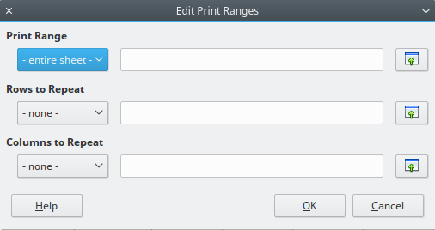
Figure 42: Edit Print Ranges dialog

Page breaks
While defining a print range can be a powerful tool, it may sometimes be necessary to manually adjust the Calc printout manually using a manual or page break. A page break helps to ensure that your data prints properly according to your page size and page orientation. You can insert a horizontal page break above or a vertical page break to the left of the active cell.
For more information on manual breaks, see the Calc Guide Chapter 6 Printing, Exporting, and E-mailing.

Inserting a break
To insert a page break:
- Navigate to the cell where the page break will begin.
- Go to Insert > Page Break on the Menu bar.
- Select Row Break to create a page break above the selected cell.
Select Column Break to create a page break to the left of the selected cell.

Deleting a page break
To remove a page break:
- Navigate to a cell that is next to the break you want to remove.
- Go to Edit > Delete Page Break on the Menu bar.
- Select Row Break or Column Break as needed.
- Note
Multiple manual row and column breaks can exist on the same page. When you want to remove them, you have to remove each break individually.

Headers and footers
Headers and footers are predefined pieces of text that are printed at the top or bottom of a page when a spreadsheet is printed. Headers and footers are set and defined using the same method. For more information on setting and defining headers and footers, see the Calc Guide Chapter 6 Printing, Exporting, and E-mailing.
Headers and footers are also assigned to a page style. You can define more than one page style for a spreadsheet and assign different page styles to different sheets within a spreadsheet. For more information on page styles, see the Calc Guide Chapter 4 Using Styles and Templates.

Setting a header or footer
To set a header or footer:
- Navigate to the sheet that you want to set the header or footer for.
- Go to Format > Page on the Menu bar to open the Page Style dialog (Figure 43).
- On the Page Style dialog, select Header or Footer tab.
- Select the Header on or Footer on option.
- Select Same content left/right option if you want the same header or footer to appear on all the printed pages.
- Set the margins, spacing, and height for the header or footer. You can also select AutoFit height box to automatically adjust the height of the header or footer.
- To change the appearance of the header or footer, click on More to open the borders and background dialog.
- To set the contents, for example page number, date and so on, that appears in the header or footer, click on Edit to open the style dialog.
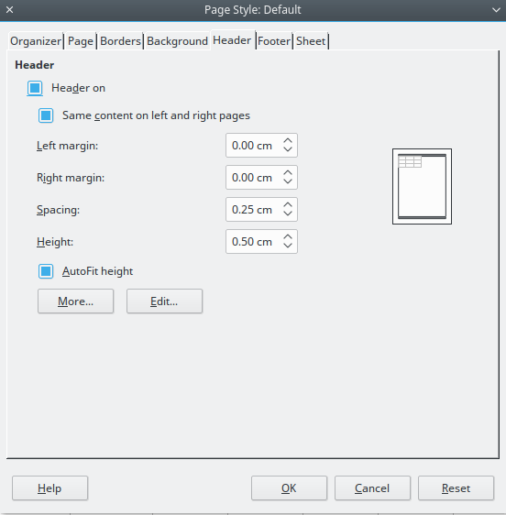
Figure 43: Header page of Page Style dialog

